APPENDIX 2
Sections through the site showing heights and massing

- Section through Staverton Road looking north, showing height and massing of the proposed Staverton Road Villa (No.27)

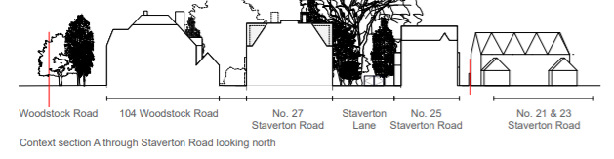

- Section through (Top) from Banbury Road to Woodstock Road showing height and massing of the proposed Walnut Lawn Villa and Terrace Pavilion and;
(Bottom) Woodstock to Banbury Rd showing height and massing of the proposed nursery Woodstock Pavilion, Water Court Villas and Walnut Lawn Villa.

